

Level 2

Questionnaire Design

Workbook

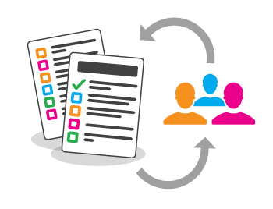

## Name:



**By Liz Sneddon**

# Design Process

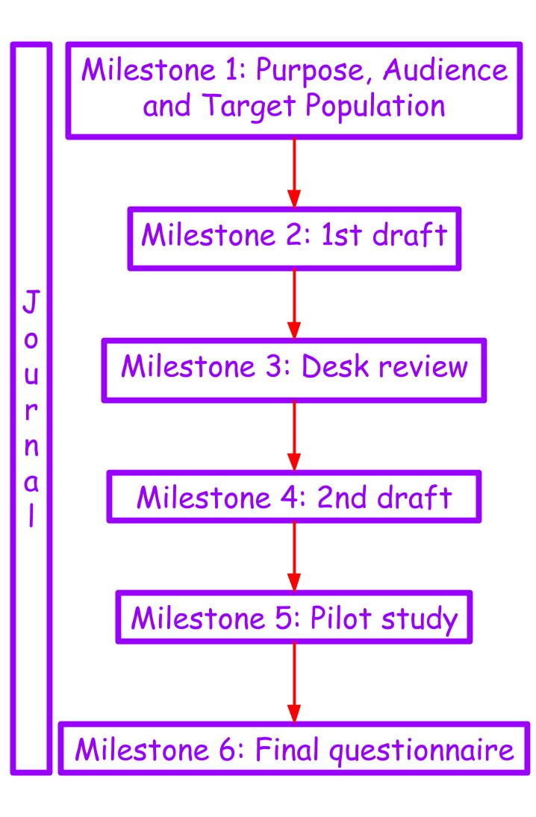

# Background information

A **questionnaire** is a series of questions asked of a group of people in order to get statistically useful information. Questionnaires are frequently used in marketing and social research.

A **survey** is when we give a **questionnaire** to a group of people (our **target population**).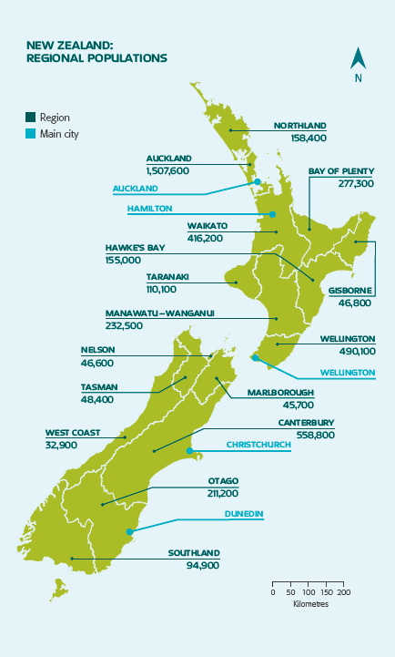

A **census**, is when **all people** in a population complete a **questionnaire**.

* The government collects data every 4 years.
* It helps government, councils and businesses to plan for the future.
* The last census in 2013 cost over $100 million dollars.
* It took more than 6 months to collect the data from every person in NZ (over 4.2 million people).

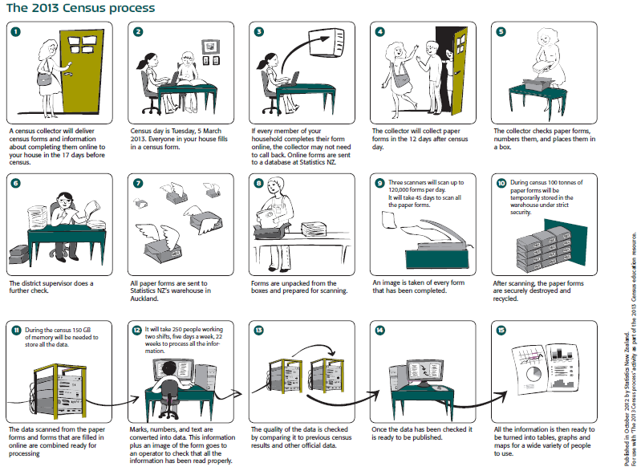

A **population** is all the individual members or items that make up a group.

A **sample** is a group of individuals (or items) selected from the population.

##### 

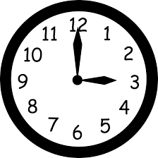

The reasons we take samples are:

* It takes a long **time** to do a census.
* It costs a lot of **money** to collect that much data.

#### Exercise:

1. Describe the population of Ormiston Senior College (be specific).

### 

1. Why don’t we sample the entire population?

### 

### 

3. How accurate is the information from a census compared with a sample? Explain.

### 

4. What does the government use the data collected from the census for? Explain.

### 

Use the following scenarios to identify populations and samples.

5. A beverage company wanted to see if people in the United States liked their new logo. Which choice best represents a population?

A. A selection of logo artists.

B. Every person in the United States.

C. A selection of shoppers from different states.

D. 3,800 children age 5 - 15

6. A musician wanted to see what people who bought his last album thought about the songs. Which choice best represents a sample?

A. Every person who bought the album.

B. A selection of people who didn't want to buy the album.

C. 250 girls who bought the album.

D. A selection of 3,294 people who bought the album.

7. A gaming website wanted to find out which console its visitors owned. Which choice best represents a population?

A. Visitors to the 3DS section.

B. All of the website visitors.

C. Visitors to the PS4 section.

D. Visitors who are on the website for more than 5 minutes.

8. Before a nationwide election, a polling place was trying to see who would win. Which choice best represents a sample?

A. A selection of voters over age 50.

B. A selection of male voters.

C. A selection of voters of different ages.

D. All voters

## Journal

Throughout the whole design process, you will need to keep a journal to record decisions, dates, progress and explanations.

Many jobs require a journal or log book to record this information as part of your job. For example, truck drivers need to record distances travelled on each day, trip etc.

For the assessment you will have a journal to complete throughout the process.

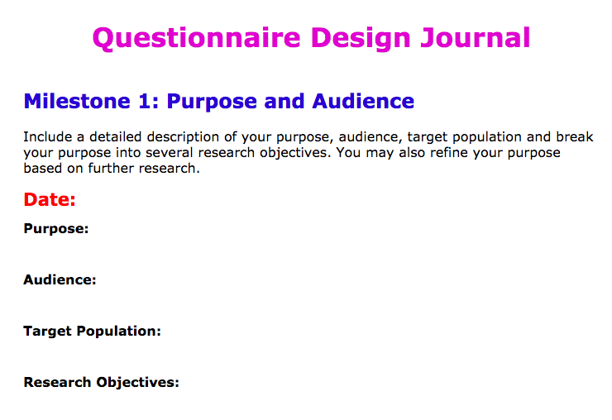

**Milestone 1: Purpose, Audience & Target Population**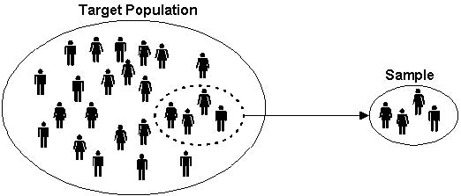

The **target population** is the group of people we want to get information from.

A **sample** is a group of individuals (or items) selected from the population.

The **sampling frame** is a **list** of people from your target population.

**Respondents** are the people who respond to the survey.



**Purpose** - the reason for which something is done or created; an intention.



**Audience** - the people who want to know the results of the questionnaire.

### Example:

A questionnaire is to be developed to explore issues concerning the school canteen.

Groups that could be interested in such a questionnaire include:

1. The canteen management committee, or
2. The board of trustees, or
3. The student council.

The purpose depends on the Audience. We’ll look at each of the audiences above.

**Audience 1: The canteen management committee**

Purposes:

* Does the current menu meet the needs of staff and students?
* Is the pricing of menu items acceptable to staff and students?

**Audience 2: The board of trustees**

Purposes:

* Does the menu match the Ministry of Educations healthy food in schools policy?
* Are staff and students frequently using the canteen?
* Are staff and students happy with the menu and service?

**Audience 3: The student council**

Purposes:

* What is the level of student satisfaction with the school canteen?
* How nutritional is the food available from the canteen?

### 

### Exercise:

A coffee shop at Botany Junction wants to give a free biscuit with each cup of coffee sold, as a promotion, and wants to survey customers to find out what sorts of biscuits their customers prefer.

Identify the purpose and audience.

## Target Population

## In order to figure out who your target population is, start by thinking about demographic information.

* Age
* Gender
* Ethnicity
* Income levels
* Education levels
* Occupation
* Location
* Household size
* Marital status

### Example:

A questionnaire is to be developed to explore issues concerning the school canteen.

The **target population** depends on the **purpose**. We’ll look at one of the audiences.

**Audience 1: The canteen management committee**

Purposes:

* Does the current menu meet the needs of staff and students?
* Is the pricing of menu items acceptable to staff and students?

Target population:

* Staff
  + Age: above the age of 20
  + Gender: male or female
  + Ethnicity: any ethnicity
  + Income levels: Teachers and support staff who have enough spare money to buy lunch (e.g. single people, people with older children
  + Location: people who work at OSC
* Students
  + Age: Year 11 - 13 students
  + Gender: Male and female
  + Ethnicity: Any ethnicity
  + Income levels: Students who work themselves, or with parents who have sufficient income to buy lunch at school.
  + Location: students who attend OSC

### Exercise:

A coffee shop at Botany Junction wants to give a free biscuit with each cup of coffee sold, as a promotion, and wants to survey customers to find out what sorts of biscuits their customers prefer.

Identify the target population.

## Research objectives

We want to take the purpose, and break this down into several research objectives. (This will then lead us easily into writing questions.)

Brainstorming is a good way to do this.

### Example:

The school council is designing a questionnaire to determine students’ satisfaction with the school canteen.

**Research objectives:**

* Determine how much students currently spend at the canteen.
* identify how satisfied students are with the canteen at the present time.
* Estimate how many times per week each student uses the canteen on average.
* Compare how much the canteen is used on different weekdays.

### Exercise:

A coffee shop at Botany Junction wants to give a free biscuit with each cup of coffee sold, as a promotion, and wants to survey customers to find out what sorts of biscuits their customers prefer.

Do a mind map and come up with some research objectives.



**Milestone 2: 1st draft**

Your first draft questionnaire should have the following items:

* A title,
* A brief description of the purpose,
* An indication of how long it will take someone to complete the questionnaire,
* A statement about the data being anonymous and confidential,
* Short clear instructions on how to fill in the questionnaire,
* A screening question,
* A thank you for their participation at the end of the questionnaire,
* Instructions on what to do when they are finished.

### Example:

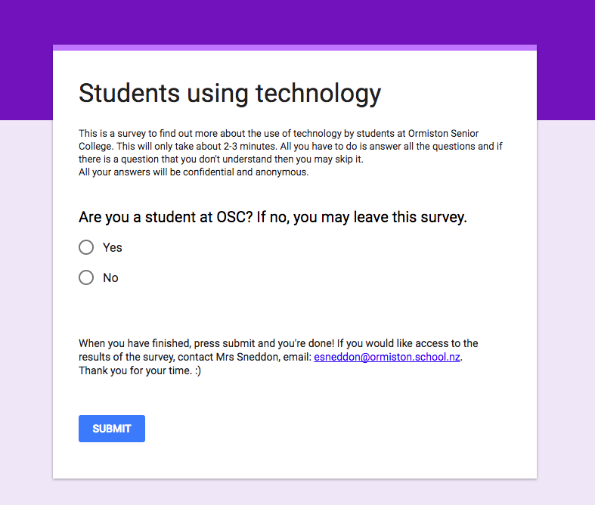

Next we will look at different survey methods, and different types of questions.

## Survey methods

Common survey methods include:

* Face to face interview
* Pen and paper
* Internet
* Email
* Telephone

Each of these methods has different **advantages** and **disadvantages**. Some of the factors to consider are:

* Bias
* Accuracy
* Response rate
* Cost
* Time to administer
* Geographical area coverage
* Sensitive questions
* Videos, sound, graphics
* Which method best suits the target population

### Bias

Bias is an inclination or prejudice for or against a person or group. We don’t want our data to be biased. There are several forms of bias that may be present:

|  |  |  |
| --- | --- | --- |
| Interviewer bias | Accessibility bias | Self-selection bias |

### 

### Accuracy

We want the answers that respondents give to be as accurate as possible.

One way to improve accuracy is to make the survey **anonymous or confidential**.

### If it is anonymous, people are more likely to give truthful answers.

### Response rate

The response rate for your survey is the percentage of people who respond. Alternatively, think about it as the number of people who respond to your survey divided by the number or people you asked to do your survey. 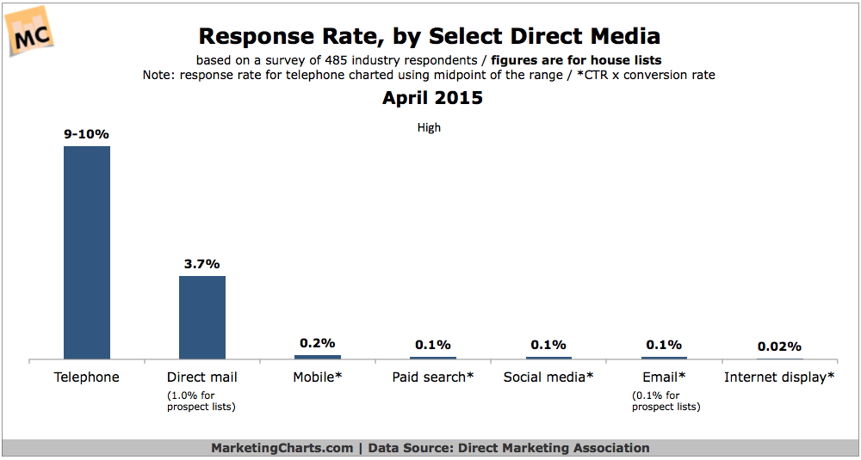

You want your response rate to be as high as possible. Different survey methods give different typical response rates, as shown from a sample below. (Note: The graph doesn’t show the response rate for face-to-face interviews, which are typically higher.)

### Cost

### Depending on your budget, you may choose different methods which have higher or lower costs.

### 

### Time to administer

Some survey methods take more time to send out and collect answers from.

### Geographical area coverage

Depending on your target population, you may want a wide or small geographical coverage

For example, if your target population is staff and students at OSC, this is a small geographical area. Whereas if your target population is teenagers who enjoy computer games, this is a very wide geographical area to cover.

### Other factors

If you want to gather information on sensitive subjects, such as alcohol use, drug use, sexual health etc, then a face to face interview is more likely to get detailed and honest answers. Whereas an email questionnaire on sensitive issues is likely to get little to no responses, or only surface information.

If you have a video or audio message that you want people to watch or listen to, then a postal survey is not the right method to use. Instead, an online survey - either using email or the internet allows video and audio to be used.

Depending on the demographics of your target population, it may be that one of the survey methods is better than others. For example, if your target population includes retired people, then a postal or phone survey may be better than either email or online surveys, as retired people are less likely to be regular users of the internet and email.

### Example:

The school council is designing a questionnaire to determine students’ satisfaction with the school canteen.

**Survey method:**

As my target population is staff and students at OSC, I will do a **online survey** as I can easily send out an email to all people at OSC using the mailing list. Below are some of the advantages and disadvantages of choosing this method:

* Bias - all students either have their own device, or are able to access one at school. This means that the accessibility bias is minimised, which increases the validity of the answers we will get.
* Response rate - an online survey usually has quite a low response rate, which is a disadvantage. Ideally it would be best to have as high a response rate as possible, so that I gather the most information from as many people who use the school canteen, so that my data **represents** my target population. I will try to increase the response rate by asking my friends to fill in the survey for me.
* Accuracy - I am making the survey anonymous, so that it will encourage people to give truthful answers.
* Cost - an online survey has no actual cost associated with it, other than my time. This is a definite advantage.
* Time to administer - online surveys are very quick to send out. Google forms also very quickly collects the answers and displays them, so processing the data takes almost no time at all.
* Geographical area coverage - I am only wanting to send out the survey to staff and students at OSC, which is a small geographical area. Therefore an online survey is fine for this as I have access to all staff and student emails.
* Sensitive questions - I don’t intend to ask any sensitive questions, so an interview is not necessary.
* Videos, sound, graphics - if I want to include videos or audio recordings, then online surveys have a definite advantage here. Using google forms also makes the layout user friendly and nice to look at.
* Which method best suits the target population - online is a good method for busy staff and students, as they can do the survey when they have a moment free.

### 

### 

### Exercise:

1. Can you think of ways to increase your response rate?
2. A coffee shop at Botany Junction wants to give a free biscuit with each cup of coffee sold, as a promotion, and wants to survey customers to find out what sorts of biscuits their customers prefer.

Suggest a survey method (not online), and discuss the advantages and disadvantages of this method.

## Question types

In your questionnaire, you must have **at least 3** different types of questions (this is a requirement of the Achievement Standard). The different types are:

* Open
* Closed
  + Yes / No
  + Checklist
  + Ranking
  + Rating (likert scales)

|  |  |  |
| --- | --- | --- |
| **Question type** | **Advantages** | **Disadvantages** |
| **Open** | * Question doesn’t lead the respondent * Respondent doesn’t have to read through a long list of responses * More richer and detailed data as respondent thinks more deeply | * Harder to analyse results * Answers can be misinterpreted, incomplete, etc. * Takes longer to complete for respondent, may mean less people want to start or complete the questionnaire |
| **Closed** | * Numerical data is easier to analyse * Easier and quicker to enter data * Easier and quicker for people to answer, so they are more likely to complete the questionnaire. | * Not all possible answers are available * Choices available may influence respondents * Respondents might not think deeply about the question |

### 

### Non response

This is when a respondent doesn’t answer all the questions. We can minimise this by:

* Keep it simple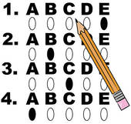
  + Short and quick,
  + Simple easy to read questions,
  + Presentation well spaced,
  + Clear instructions,
  + Anonymity and confidentiality,
  + Thank you at the end.

## Question design tips

|  |  |
| --- | --- |
| Tip | Example |
| Make sure that you add **instructions** if the possible responses are not clear | tick one box only OR tick all that apply |
| **Checkboxes** should be used for responses that are known *ie* days of the week, times, age categories, etc. | On which weekday are you most likely to socialise with friend (circle answer)  Monday Tuesday Wednesday Thursday Friday |
| **Other with comment** should be used if additional information may be useful. Other on its own may not be of much use when analysing data. | What is your favourite junk food?  piessweetscakesother  If you answered other, what is it? *____________________________* |
| **Open questions** should be used only when the responses can be quite varied, so the researcher cannot readily identify the expected answers. |  |
| **Yes/no answers** often require follow-up questions | Do you smoke every day? (circle answer) Yes/no  *followed by:*  If you said yes, give an indication of how many cigarettes you smoke a day.  **A** 1 to 5  **B** 6 to 10  **C** 11 to 20  **D** 21 to 30  **E** more than 30 |
| **Skips** are useful when not everyone needs to answer all questions | 5. Do you smoke? (circle answer)  Yes/no  *followed by:*  If you said **no**, go to question 8. |

## 

## 

## Writing questions

|  |  |
| --- | --- |
| We want data that is:   * Accurate, * Unbiased, * High response rate, * Quick for respondents to answer, * Useful and meets the purpose. | Good questions are:   * Specific, * Get truthful answers, * Fair (not misleading), * Clear and simple language, * Clear definitions, * Correct grammar and spelling, * Keep the questionnaire as short as possible. |

Things to avoid:

|  |  |
| --- | --- |
| Double negatives | Jargon or slang |
| Double barrelled questions | Overlapping response categories |

|  |  |  |
| --- | --- | --- |
| Offensive language | Embarrassing questions | Too many questions |

### Example:

The school council is designing a questionnaire to determine students’ satisfaction with the school canteen.

**Research objectives:**

* Determine how much students currently spend at the canteen.
* identify how satisfied students are with the canteen at the present time.
* Estimate how many times per week each student uses the canteen on average.
* Compare how much the canteen is used on different weekdays.

**Draft Questions**

1. Do you buy your lunch at the school canteen last week?
   1. Yes please continue to question 2
   2. No thank you for your time, you don’t need to continue.
2. How much money did you spend at the canteen last week?
   1. $0
   2. $1 - $5
   3. $6 - $10
   4. $10 - $15
   5. more than $16
3. Would you have spent more money if different foods were available?
   1. Yes
   2. No
4. How satisfied are you with the foods available at the canteen?

not at all very satisfied

0 1 2 3 4 5

5. How satisfied are you with the drinks available at the canteen?

not at all very satisfied

0 1 2 3 4 5

6. How many days per week did you buy your lunch last week?

1. 1
2. 2
3. 3
4. 4
5. 5

7. Which days did you buy your lunch last week? (Tick all that apply.)

* I didn’t buy my lunch
* Monday
* Tuesday
* Wednesday
* Thursday
* Friday

### Exercise:

A coffee shop at Botany Junction wants to give a free biscuit with each cup of coffee sold, as a promotion, and wants to survey customers to find out what sorts of biscuits their customers prefer.

Write at least 6 questions. You may want to refer back to the research objectives you came up with on page 10.

# Data Types

**Qualitative (groups) variables** are characteristics, that cannot be described by numbers e.g. gender, ethnicity, apple variety.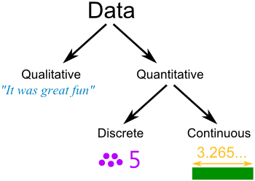

**Quantitative (numerical) variables** are characteristics described by numbers e.g. height, age, number of apples, weight. Numerical variables are either **discrete** or **continuous**.

**Discrete variables** (whole numbers), values obtained by counting.

**Continuous variables** (measurement), values obtained by measuring.

### Example:

The school council is designing a questionnaire to determine students’ satisfaction with the school canteen.

|  |  |
| --- | --- |
| **Draft questions** | **Data type** |
| 1. Do you buy your lunch at the school canteen last week?    1. Yes please continue to question 2    2. No thank you for your time, you don’t need to continue. | Qualitative |
| 1. How much money did you spend at the canteen last week?    1. $0    2. $1 - $5    3. $6 - $10    4. $10 - $15    5. more than $16 | Quantitative  Continuous |
| 1. Would you have spent more money if different foods were available?    1. Yes    2. No | Qualitative |
| 1. How satisfied are you with the foods available at the canteen?   not at all very satisfied  0 1 2 3 4 5 | Quantitative  Discrete |
| 5. How satisfied are you with the drinks available at the canteen?  not at all very satisfied  0 1 2 3 4 5 | Quantitative  Discrete |
| 6. How many days per week did you buy your lunch last week?   1. 1 2. 2 3. 3 4. 4 5. 5 | Quantitative  Discrete |
| 7. Which days did you buy your lunch last week? (Tick all that apply.)   * Monday * Tuesday * Wednesday * Thursday * Friday | Qualitative |

### Exercise:

A coffee shop at Botany Junction wants to give a free biscuit with each cup of coffee sold, as a promotion, and wants to survey customers to find out what sorts of biscuits their customers prefer.

Look at the draft questions you wrote on page 21 and state what data type they are.

## Google forms

Once you have written your questions, enter them into a Google form.

|  |  |  |
| --- | --- | --- |
| **Step 1:**  Open a new Google form | **Step 2:**  Enter a title and any instructions. | **Step 3:**  Type in your first question. |
| **Step 4:**  Choose the question type. | **Step 5:**  Choose a question type. | **Step 6:**  Enter the possible answers. |
| **Step 7:**  If you want to make the question compulsory for everyone, then click the required button. | **Step 8:**  Click on the “+” button to add a new question. |  |

### 

### Exercise:

A coffee shop at Botany Junction wants to give a free biscuit with each cup of coffee sold, as a promotion, and wants to survey customers to find out what sorts of biscuits their customers prefer.

Look at the draft questions you wrote on page 21 and enter them into a Google form.

**Milestone 3: Desk Review**

Now that you have a first draft of the questions, your next step is to review these, and get someone else to review them. This process is called a desk review.

There is a template available that you can use to do a desk review.

### Order of questions

* Screening question first.
* Demographic questions (age, gender, location etc) leave until last, unless they are needed for screening.
* Group the questions together by topic.

**Checklist for desk review**

|  |  |  |
| --- | --- | --- |
|  | **OK?** | **Comment** |
| **Introduction** | | |
| Meaningful Title |  |  |
| Purpose is clear |  |  |
| Indication of how long it will take to complete the questionnaire |  |  |
| Clear instructions of how to complete |  |  |
| Anonymity statement |  |  |
| **Questions:** | | |
| Target Population identified and screened for |  |  |
| Does the question meet the purpose and research objectives? |  |  |
| Question is clear, easy to understand |  |  |
| All possible answers are catered for |  |  |
| At least 3 different types of questions (e.g. multi-choice, open, etc) |  |  |
| Instructions given where appropriate  ie *tick all that apply* or *tick one only* |  |  |
| Are any questions repeated or unnecessary? |  |  |
| Are there questions missing which would be important for the purpose? |  |  |
| Appropriate language, spelling, grammar, etc |  |  |
| Questions in logical order |  |  |
| Questions will give responses that are easily analysed |  |  |
| **Conclusion** | | |
| Instructions for what to do with completed questionnaire included |  |  |
| Thank you included |  |  |
| How to access results of survey (if respondent wants to see) |  |  |
| **Overall presentation of questionnaire** | | |
| Layout is clear and uncluttered |  |  |

### Exercise:

Identify what is wrong with the following questions and rewrite them.

|  |  |  |  |
| --- | --- | --- | --- |
|  | **Question** | **What is wrong?** | **Rewritten question** |
| 1 | How often do you buy cosmetics? Circle 1  A every week  B once a month  C every three months  D every 6 months or more |  |  |
| 2 | How much do you spend on cosmetics in a month?  A less than $50  B between $50 and $100  C more than $100  D none |  |  |
| 3 | Do you agree or disagree with the following statement:  *I felt welcomed by both the staff and students at school.* |  |  |
| 4 | Do you agree or disagree with the following statement:  *We should not reduce spending on public health services.* |  |  |
| 5 | Is Colgate your favourite toothpaste?   * Yes * No |  |  |
| 6 | How long did you spend in the gym today?   * less than 30 minutes * less than 45 minutes * less than 60 minutes * 60 minutes or more |  |  |
| 7 | Do you agree that single sex schools are better than co-ed schools?   * Yes * No |  |  |
| 8 | How much fizzy drinks do you drink each week?   * None * A little * Quite a bit * A lot |  |  |
| 9 | How much do you like your cellphone? Give a rating from 1 to 5. |  |  |
| 10 | How many cars does your family have?   * 1 car * 2 cars * 3 cars |  |  |
| 11 | Why are social networking sites harmful? |  |  |
| 12 | What is your NZQA NSN? |  |  |

### Exercise:

A coffee shop at Botany Junction wants to give a free biscuit with each cup of coffee sold, as a promotion, and wants to survey customers to find out what sorts of biscuits their customers prefer.

Look at the draft questions you entered into a Google form on page 23. Swap your questionnaire with another student and carry out a desk review on their questions (your teacher will have the desk review form for you to use). You should take at least 5 minutes to do a proper desk review.

Look at the feedback you received from the desk review, and explain and justify any changes you will make.



**Milestone 4: 2nd draft**

When your desk review is completed, you can the make changes to your questionnaire. For your assessment, you want to have at least 3 changes that you have identified and justified.

### Exercise:

A coffee shop at Botany Junction wants to give a free biscuit with each cup of coffee sold, as a promotion, and wants to survey customers to find out what sorts of biscuits their customers prefer.

Make the changes to your Google form that you decided on after your desk review.



**Milestone 5: Pilot study**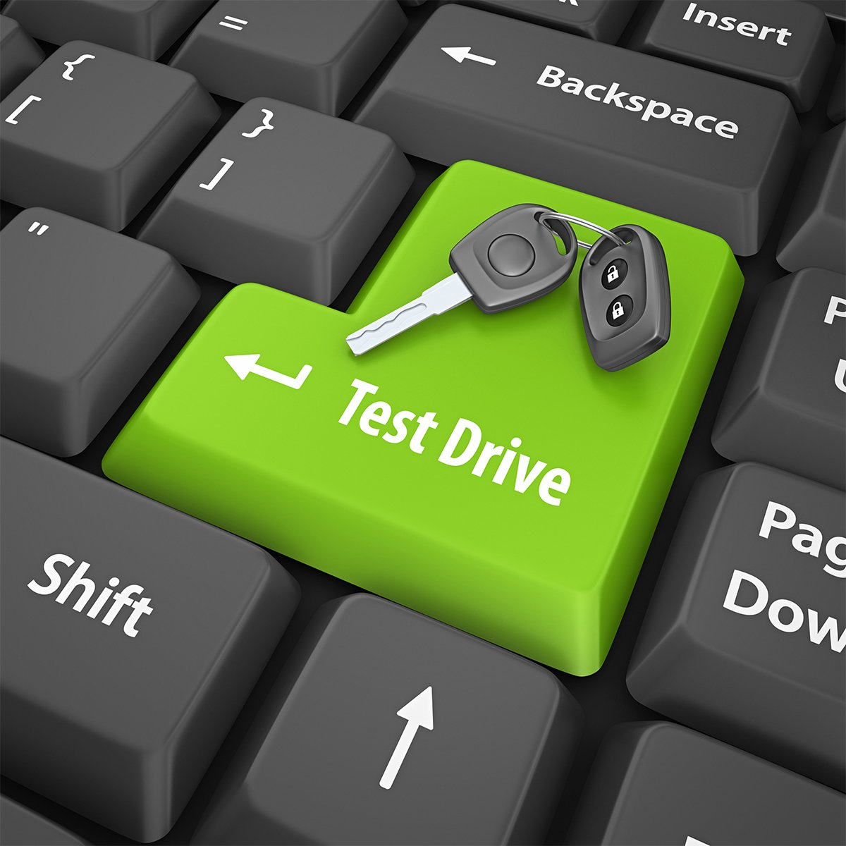

This is where you do a test drive of your questionnaire with a few students.

We do this to get feedback on how we can improve the questionnaire.

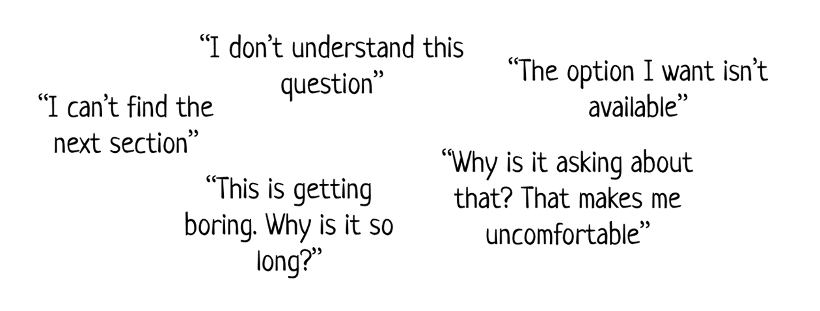

### 

### 

### Exercise:

A coffee shop at Botany Junction wants to give a free biscuit with each cup of coffee sold, as a promotion, and wants to survey customers to find out what sorts of biscuits their customers prefer.

Send your Google form out to 5 students asking them to fill in your form and give you feedback. You may want to ask specific questions, such as:

* How long did it take you to fill it in?
* Were there any questions you didn’t understand?
* Were there any answers that weren’t available?
* Was the wording in each question clear?

Look at the feedback you received from the pilot study, and explain and justify any changes you will make.

Also look at the graphs (in the response section) to check if the data is as you expected.



**Milestone 6: Final questionnaire**

The last step is to finalise any changes to your questionnaire after the pilot study. You also want to reflect whether your questionnaire meets the purpose.

For this assessment, you would be finished after completing this step (and finishing your journal / log book).

However, if this was a real questionnaire, you would now continue on, select a sample using a random sampling method, and then distribute your questionnaire to the target population. Ideally, you want a sample size of **at least 30**.

For those continuing onto the Business Studies assessment, you will need to distribute your questionnaire onto your target population to collect information.

## Working towards Merit and Excellence

In your log book, you should be recording every choice you make and the reasons why you make it, relating each decision to the purpose of the questionnaire and/or the target population and the wider context. When you have completed, evaluate the whole process and the final version of the questionnaire.

### Exercise:

A coffee shop at Botany Junction wants to give a free biscuit with each cup of coffee sold, as a promotion, and wants to survey customers to find out what sorts of biscuits their customers prefer.

Finalise your questionnaire.

Reflect on whether your questionnaire meets the purpose and needs of the audience.



## 

Fill in the planned completion dates, and when you have finished each Key skill, show your teacher so they can track your progress.

|  |  |  |  |
| --- | --- | --- | --- |
| **Milestone** | **Workbook pages** | **Planned Completion Date** | **Completion Date (teachers sign)** |
| Background info | 2 - 6 |  |  |
| 1 | 7 - 11 |  |  |
| 2 | 12 - 24 |  |  |
| 3 | 25 - 28 |  |  |
| 4 | 29 |  |  |
| 5 | 29 - 30 |  |  |
| 6 | 31 |  |  |